Human Resource Policy

Section 4: Employee Benefits
CRCPL offers a competitive benefit package to employees classified as Regular full-time and Regular part-time. We are also able to offer a select number of benefits to part-time employees scheduled to work between 20 to 29 hours per week, as defined below. Student employees that are Temporary/Seasonal or employed as part of a Practicum/Internship are not benefit eligible.
Regular full-time is defined as an employee scheduled 40 hours per week.
Regular part-time is defined as an employee regularly scheduled between 30 to 39 hours per week.
Part time is defined as an employee regularly scheduled between 20 to 29 hours per week.

4.4 TYPES OF LEAVE
The leave package was developed to assist employees in creating a healthy work/life balance. Employees are responsible for managing their paid time off. Exceeding the limit of authorized paid/unpaid leave will lead to corrective action (HR policy 2.8).
4.4.1 Vacation Leave
Vacation with pay is granted to all regular full-time, regular part-time employees and part-time employees who are scheduled to work at least 30 hours per week. Regular part-time employees who work fewer than 30 hours per week do not qualify for vacation with pay, but may arrange with their supervisors for unpaid leave as outlined in the Attendance Policy.
A new employee who has service credit with the State of Ohio or any political subdivision of the State (i.e., township, municipality, library, school district, health district, etc.) may use prior service credit for the purpose of computing vacation leave. Employees must submit a service credit statement to certify eligible years of service. Employees who have retired from a state-offered retirement plan are not entitled to have prior service counted for the purposes of computing vacation leave.
With prior approval of the Executive Director and the Chief Fiscal Officer, an employee may “borrow” against vacation expected to be earned during the current calendar year, provided such “borrowing” is not in excess of the total vacation for which the employee is eligible to earn in that calendar year. In no case may an employee “borrow” against vacation to be earned in a succeeding calendar year.
An employee who has “borrowed” vacation time and who leaves employment with a deficit of earned vacation time will reimburse CRCPL for the difference of the value between the vacation time used and the vacation time actually earned by the employee at the date of the employee’s separation from service by deduction from the employee’s last paycheck.
Vacation leave accrues at the following rates:
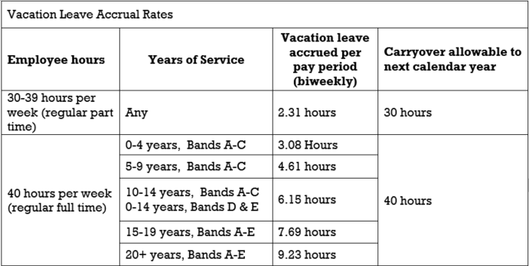
ADD ROW: 20-29 hours per Any 1.54 (50%) 20 hours
week (part time)

4.4.2 Sick Leave
Sick leave is accrued by all regular full-time employees and regular part-time employees and part-time employees working at least 30 hours weekly. Part-time employees working less than 30 hours weekly are not eligible to accrue sick leave benefits. Time off beyond the accumulated amount of leave may be taken from vacation time with permission of the Executive Director. If no leave remains, the provisions of the Attendance Policy (HR Policy 5.3) will apply.
A new employee may transfer accumulated sick leave credit from another Ohio public library or Ohio public agency up to the maximum accumulation permitted above. The Chief Fiscal Officer will require an official accounting of hours from the employee’s previous public employer.
Sick leave accrues at the following rates:
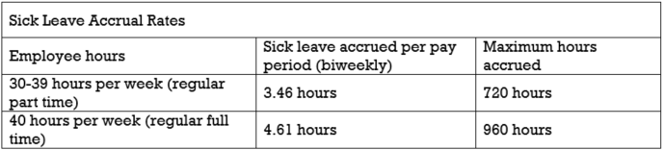
ADD ROW: 20-29 hours per 2.3 (50%) 480 hours
week (part time)
At the discretion of the Executive Director, absences may require relevant documentation. Sick leave may be used only in the following instances:
- Illness or injury to the employee.
- Illness in the immediate family requiring the presence of the employee.
- Other FMLA qualifying events.
- Death in the immediate family: spouse, children and stepchildren (whether dependent or not), siblings, parents, grandparents, and grandchildren; or death of a relative living in the same household; or at the discretion of the Executive Director.
- Time used for visits to doctors and dentists, etc., may be counted as sick leave, but this practice is not encouraged and should be used only when appointments cannot be made outside working hours.
4.4.3 Personal Leave
Regular full-time employees are entitled to 24 hours of personal leave, and regular part-time employees working at least 30 hours weekly are entitled to 18 hours personal leave, in each calendar year in which they work. Personal leave must be used in the calendar year in which it is earned, and is not eligible to be paid out upon separation of employment.
4.4.4 Wellness Leave
All employees who participate in the Wellness program, regardless of their current benefits, are eligible to receive 4 hours of paid Wellness Leave each year they participate in the program. This leave must be taken within 12 months from when it’s earned, and is not eligible to be paid out upon separation of employment.
4.4.5 Part Time Paid Leave
At the beginning of the calendar year, part-time (employees working less than 30 hours per week) employees will be given paid leave equal to the normal total of hours scheduled per week. The leave will be credited to the employee as a lump sum at the start of each year and may be used to cover illness, vacation, or any other occurrence that may result in a loss of pay for the employee. Part time paid leave must be used in the calendar year in which it is allotted, and is not eligible to be paid out upon separation of employment.
Exceeding the limit of authorized paid and/or unpaid leave will lead to discharge.

5.3 ATTENDANCE
CRCPL depends heavily upon its employees, it is important that employees attend work as scheduled. Dependability, attendance, punctuality and a commitment to do the job right are essential at all times. To the extent permitted by law, absenteeism and tardiness lessen an employee’s chances for advancement, and may result in corrective action up to, and including, discharge of employment.
Unless required by law, regular full-time and regular part-time employees who have exhausted all of their paid leave (HR policy 4.4), may use up to 5 additional unpaid working days within the calendar year equal to their normal total hours scheduled per week. Prior approval of the Executive Director is required for unpaid leave.
Part-time employees may use up to 10 working days as authorized in unpaid absence from work within the calendar year equal to the normal total of hours schedule per week.
Non-medical unpaid absences should only be approved when they do not create a hardship for the library or adversely impact the work unit. Requests for unpaid leave should be made as far in advance as possible.
An employee must personally (unless incapacitated) notify their supervisor or administration if they expect to be late or absent as far in advance as possible but within one hour after the scheduled work time.
Supervisors have the right to ask the reason for tardiness/absence; if due to medical necessity the exact nature of an illness need not be divulged. An employee should attempt to provide an estimated arrival time or day of return to work.
Failure to call in, in a timely manner, may result in corrective action. Employees who do not return to work or arrive at the time originally estimated are expected to call in again. Supervisors will track all employees’ absences to ensure that absences and tardiness are not excessive. Generally speaking, more than 10 unscheduled absences or late arrivals at work in a 12-month period is considered excessive. Corrective action, up to and including discharge, will be used to deal with excessive unscheduled absence/tardiness that is not covered under FMLA.

