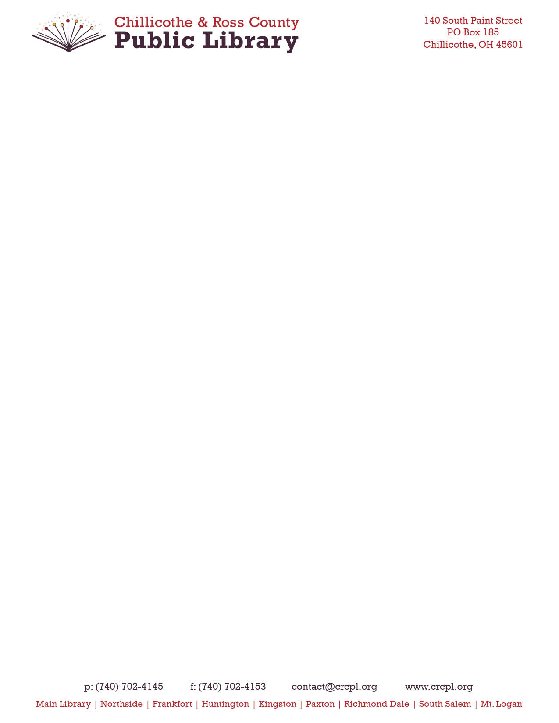

**Resolution For Fringe Benefit Pick-up Plan**

RESOLUTION NO. ____________

The Chillicothe & Ross County Public Library will pick up the statutorily required contribution to the Ohio Public Employees Retirement System for the employees established in section 2 herein, pursuant to IRC section 414(h)(2).

WHEREAS, pursuant to federal and Ohio laws, the Chillicothe & Ross County Public Library may offset future salary increases and “pick up” (assume and pay) the contributions statutorily required by such elected officials and covered employees to the Ohio Public Employees Retirement System (OPERS) and such individuals will not be required to pay federal and state income taxes on such contributions; and

Now therefore be it ordained by the Chillicothe & Ross County Public Library, that:

**SECTION 1**: Effective January 1, 2023 the full amount of the statutorily required employee contributions to OPERS shall be picked up and paid as a fringe benefit by the Chillicothe & Ross County Public Library for each person within any of the classes established in Section 2 herein. The pick-up shall be an offset against future salary increases. This “pick up” by the Chillicothe & Ross County Public Library shall be designated as public employee contributions and shall be in lieu of contributions to OPERS by each person within any of the classes established in Section 2 herein. No person subject to this “pick up” shall have the option of choosing to receive the statutorily required contribution to OPERS directly instead of having it “picked up” by the Chillicothe & Ross County Public Library or of being excluded from the “pick up”. The Chillicothe & Ross County Public Library shall, in reporting and making remittance to OPERS, report that the public employees contribution for each person subject to this “pick up” has been made as provided by the statute. Therefore, contributions, although designated as employee contributions, are employer-paid, and employees do not have the option to receive the contributions directly. All contributions are paid by the employer directly to the plan.

**Section 2:** The “pick up” by the Chillicothe & Ross County Public Library provided by this ordinance shall apply to the Executive Director and the Chief Fiscal Officer of the Chillicothe & Ross County Public Library, who are members of OPERS.

**SECTION 3:** Under the fringe-benefit method of employer pick up, salary is not modified; however, the employer will pay the employees’ statutorily required contribution to OPERS.

**SECTION 4**: The Chief Fiscal Officer is hereby authorized and directed to implement the provisions of this ordinance to institute the “pick up” of the statutorily required contributions to OPERS for those persons reflected in Section 2 herein so as to enable them to have their employee contributions paid by their employer.

Adopted, November 9th, 2022

The roll being called, the vote resulted as follows:

(INSERT ROLL CALL VOTE)

________________________________________________ ________________________________________________

Angela Fleurima, Secretary John Owens, President