February Director’s Report

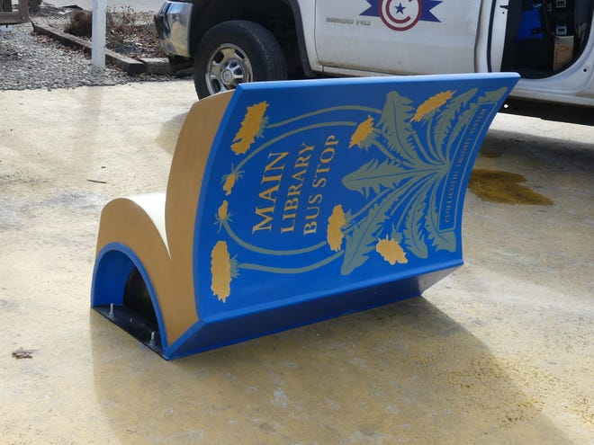
The bus stop book bench has generated a lot of buzz. The Gazette featured a photo on January 30. The artwork has several clear coats on it, so we’re hopeful it will weather okay and not be subjected to vandalism.
The warming station continues to be very popular. More than once in January we’ve surpassed 70 attendees over the course of a day. It’s taking a lot of pressure off Main during the colder weather. However, since the warming station is not open on weekends, the issues (like overcrowding and “camping out”) can be exasperated then, not necessarily on staff, but on regular patrons who visit on weekends.
We’re still waiting on the final drawings and estimates for the Annex renovations. We don’t have a schedule in place yet, but we’re still aiming for early summer. The remaining bit of landscape work at the Annex should be completed in early April.
The Ohio Library Council continues to prepare for April’s Legislative Day and the biennial budget process. Governor DeWine outlined several spending priorities in his recent State of the State address, including a focus on early literacy and libraries, so there is optimism that the Public Library Fund (PLF) will continue to receive broad support. In his proposed budget, known as the Bluebook, DeWine recommended setting the PLF at 1.7% of general revenue, which is what we’ve had temporarily for the past two years—the statutory rate is 1.66%. The governor’s request puts the legislature in the position of having to argue why libraries shouldn’t be funded. We’re starting from a good position.

NEW BUSINESS:
- New Administrative Policy 12—Fixed Asset Policy [ACTION]
Cassie has been working a new policy to address our inventory accession and deaccession processes. We don’t have a current policy, so this would update and formalize our current procedures. She drafted this policy based on OLC’s guidelines and after reviewing policies from other libraries.
Currently, we tag any non-expendable that’s valued at more than $100 (was previously $50); this policy increases that threshold to $500. IT already keeps their own list of computers and related equipment. For audit purposes, we are already required to keep an updated building list and data processing software list. This policy includes non-circulating artwork (like the large Cinderella painting at Main) and also formalizes the disposal process.
- Update HR Policy 4.5—Holidays [ACTION]
A few years ago we changed our holiday policy to allow part-timers who are normally scheduled on a day that is a holiday to receive holiday pay. As new staff have been hired, the current language has caused some confusion, so I asked Kelly to clarify that holiday pay is intended only to keep your schedule whole, not to add hours to your week beyond your normal schedule.
- Huntington Library [discussion]
Last week we started hearing rumors that the Huntington School Board was not going to renew our lease for the high school library space. I reached out to Superintendent Pete Ruby, but wasn’t able to make contact until several days later (he’d been out with COVID). Mr. Ruby told me that the board hasn’t had a formal discussion, but he has had one-on-one conversations with some members and two have expressed a desire to take back the space—not because of our relationship or any dissatisfaction, but simply because they need the space to create more offices. It would be a blow to the students who use our services. Our current 3-year lease ends May 31, 2023. We need to decide how/if we want to proceed with a presence in Huntington.
- Adjourn [ACTION]

